八年級(康軒版)下學期英語科補考題庫(Lesson 1~Lesson9)
單字Vocabulary
誰的 | whose | 脖子 | neck | 昆蟲 | insect | 快速地 | fast
寄送 | send | 頭髮 | hair | 馬 | horse | 刻薄的 | mean
玫瑰 | rose | 頭 | head | 鴨子 | duck | 年齡 | age
禮物 | present | 指甲 | nail | 尾巴 | tail | 黑板 | blackboard
興趣 | interest | 膝蓋 | knee | 草 | grass | 煩惱 | trouble
蜘蛛 | spider | 鍋子 | pot | 風 | wind | 驕傲的 | pride
驚喜 | surprise | 方法 | way | 吹 | blow | 孤單的 | lonely
節日 | holiday | 分享 | share | 漁夫 | fisherman | 小心的 | carefully
約會 | date | 穿:戴 | wear | 嚴重的 | serious | 聰明的 | bright
掛 | hang | 夾克 | jacket | 安全的 | safe | 課程 | program
親吻 | kiss | 牛仔褲 | jeans | 膠帶 | tape | 便宜的 | cheap
點菜 | order | 短褲 | shorts | 紫色的 | purple | 價格 | price
嚐 | taste | 長褲 | pants | 似乎 | appear | 千 | thousand
菜單 | menu | 襯衫 | shirt | 侵襲;打 | hit | 付錢 | pay
火腿 | ham | 制服 | uniform | 百萬 | million | 分鐘 | minute
吐司 | toast | 襪子 | socks | 海浪 | wave | 欺騙 | cheat
奶油 | butter | 尺寸 | size | 部分 | part | 毛巾 | towel
賣 | sell | 洋裝 | dress | 照耀 | shine | 雨傘 | umbrella
咬 | bite | 公牛 | ox | 拍手 | clap | 沙發 | couch
肥胖的 | fat | 鯨魚 | whale | 滾動 | roll | 一半的 | half
死亡 | die | 鯊魚 | shark | 對待 | treat | 院子 | yard
殺 | kill | 袋鼠 | kangroo | 百 | hundred | 總數 | total
鈴 | bell | 綿羊 | sheep | 行動 | action | 風扇 | fan
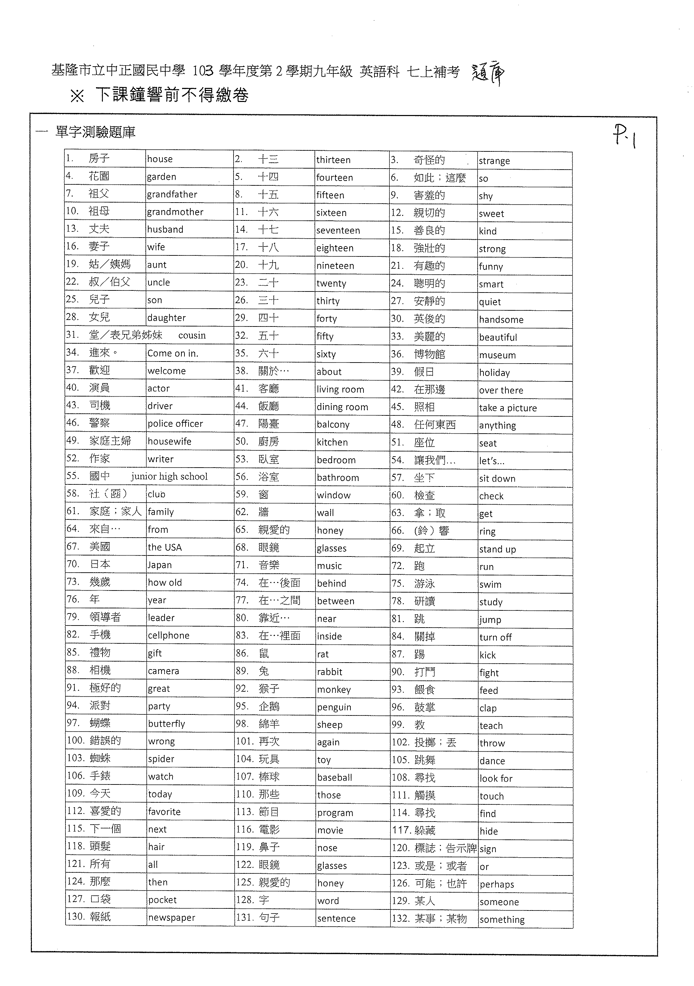
文法Grammar
C 1. Who is , Bob or Tim?
- prettier (B) the busier (C) quieter (D) longer
A 2. There are department stores in Taipei than in Tainan.
(A) more (B) less (C) fewer (D) smaller
Ｄ 3. Look at my new shoes. The right is smaller than the left .
(A) ones; ones (B) one; ones (C) ones; one (D) one; one
D 4. Is Taipei city in Taiwan?.
(A) bigger (B) biggest (C) the bigger (D) the biggest
Ｃ 5. Alice is girl at the party. All the men there want to ask her for a dance.
(A) the ugliest (B) most beautiful (C) the prettiest (D) least special
D 6. What is the most fruit of all?
(A) best (B) sweet (C) cheap (D) delicious
A 7. Meg’s stand sells fish at the market; her business is very good.
(A) the freshest (B) better (C) the fresher (D) best
C 8. It’s colder and colder. Remember to bring your heavy jacket with you.
(A) feeling (B) became (C) getting (D) smelling
A 9. Do Tim and Jenny brother and sister?
(A) look like (B) look (C) smell like (D) smell
D 10. Leo , so he can’t turn his head now.
(A) cut his finger (B) broke his nail (C)broke his leg (D) hurt his neck
C 11. My mom never lets me out.
(A) eating (B) to eat (C)eat (D) eats
Ｂ 12. Jack his wife do all the housework.
(A) asks (B)has (C)tells (D) wants
C 13. We heard Jay Chou on TV last night.
(A) sang (B)sings (C)singing (D) to sing
Ｂ 14. On windy days, we can feel the wind .
(A) blew (B)blowing (C)blows (D) to blow
C 15. of the beef comes from the USA.
(A) Both (B) A few (C) Much (D) Two
B 16. Jenny felt much better she went to a doctor.
(A) than (B) after (C) but (D) so
D 17. he died, he tried to save the girl in the sea.
(A) Because (B) After (C) When (D) Before
D 18. We’ll go camping if it next weekend.
(A) won’t rain (B) isn’t raining (C) wasn’t rainy (D) doesn’t rain
Ｃ 19. We still enjoy our holidays in Kenting it was very hot.
(A), but (B) , so
(C)though (D) because
A 20. anyone know the answer the question? .
(A) Does; to (B) Do; to (C) Does;of (D) Do; of

